Phone No.: 03483-264226
Website: jangipurcollege.in
e-mail: jangipurcollege@yahoo.com
JANGIPUR COLLEGE
(Govt. Sponsored)
(NAAC Accredited B⁺⁺)
P.O.- Jangipur, Dist.- Murshidabad, Pin-742213

Department of Chemistry

Project Titles for UG Sem I Examination 2023

Chemistry Major students are hereby notified to write a detailed report on any one of following theme:
Slater’s rule and its application
or
The concept of Electronegativity and different scales for Electronegativity determination

.

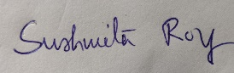

(Dr..Sushmita Roy)
Head of the Department
Department of Chemistry
Jangipur College
2/3/24

