Phone No: 03483-264226
Website: jangipurcollege.in e-mail:jangipurcollege@yahoo.com
JANGIPUR COLLEGE
(Govt. Sponsored)
(NAAC Accredited)
P.O.-Jangipur, Dist.-Murshidabad, Pin-742213
Dt. 10/08/2021

Notice:
Result UG 1st semester Examination 2020

Students are requested to downloads their results of UG 1st semester Examination 2020 from DOWNLODS MENU from college website: www.jangipurcollege.in

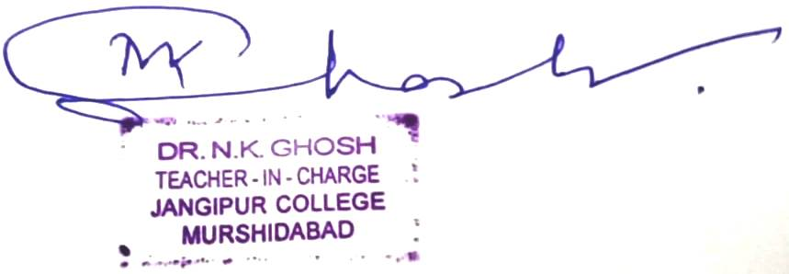

Teacher-in-Charge
Jangipur College

