Phone No: 03483-264226
Website: jangipurcollege.in e-mail:jangipurcollege@yahoo.com
JANGIPUR COLLEGE
(Govt. Sponsored)
(NAAC Accredited)
P.O.-Jangipur, Dist.-Murshidabad, Pin-742213
Dt. 12/09/2021

Notice:

This is to notify for information to the students of U.G. 4th semester who are appearing the said examination, are asked to submit a copy of 4th semester examination 2021 admit card at the time of submitting the answer scripts in mail or in hand. Pl. tick against the specific subject on the admit card copy.

Otherwise, their answer script will not be acceptable in mail or in by hand submission.

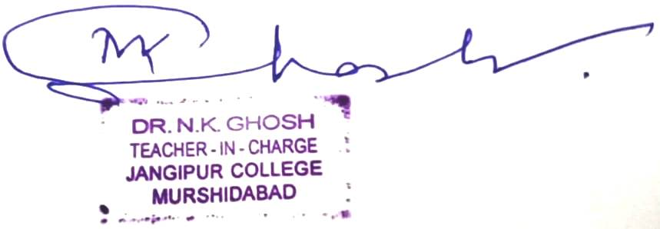
By Order,

Teacher-in-Charge
Jangipur College

